**REPORT FOR HANGMAN GAME**

**As A Project Work For Course**

**PYTHON PROGRAMMING ( INT 213 )**

Name : Saumya Singh

Registration Number : 12016570

Name : Mrinal Parasar

Registration Number : 12013541

Program : B.Tech CSE

Semester : 3rd

School : School of Computer Science and Engineering

Name of the University : Lovely Professional University

Date of submission - 30th NOVEMBER 2021

**HANGMAN GAME**

30th NOVEMBER 2021

ABSTRACT

Hangman is a paper and pencil guessing game for two or more players. One player thinks of a word, phrase or sentence and the other(s) tries to guess it by suggesting letters within a certain number of guesses.

AKNOWLEDGEMENT

I would like to thank my mentor - Prof. Dipen Saini for his advice and inputs on this project. Many thanks to my friends and seniors as well, who spent countless hours to listen and provide feedbacks.

**TABLE OF CONTENT**

|  |  |  |
| --- | --- | --- |
| S.No. | Topics | Page No. |
| 1. | Abstract | 02 |
| 2. | Acknowledgement | 02 |
| 3. | Introduction | 04 |
| 4. | Team Members with roles | 05 |
| 4. | Proposed Work | 06 |
| 5. | Screenshots | 07 |
| 6. | Conclusion | 09 |

**INTRODUCTION:-**

Hangman is a popular word guessing game where the player endeavours to construct a lost word by speculating one letter at a time. After a certain number of off base surmises, the game finishes and the player lose. The game also finishes when the player loses. The game also finishes when the player accurately distinguishes all the letters of the lost word.

The hangman program randomly selects a secret word from a list of secret words. A random word is picked up from our collection and the player gets limited chances to win the game. When a letter in that word is guessed correctly, that letter position in the word is made visible. In this way, all letters of the word are to be guessed before all the chances are over.

For convenience, we have given length of word +2 chances. For example, word to be guessed is mango, then user gets 5+2=7 chances, as mango is a five-letter word.

**TEAM MEMBER’S**

1. Saumya Singh

Contribution:

* Collection of ideas
* Installation of required modules
* Coding(joined)
* Resolved bugs and errors
* Documentation in the report

1. Mrinal Parasar

Contribution:

* Collection of ideas
* Installation of required modules
* Coding(joined)
* Resolved bugs and errors
* Documentation in the report

**Proposed Work**

We have stated working on this project 1 November.

Firstly, we have gained knowledge about GUI in python then we divided the task Mrinal worked on the algorithm of the game and in mean time Saumya have learned about classes in python.

After collecting all the required Information and knowledge about python programming and GUI using python.

Then we started the coding part we have coded the game together Mrinal did the algorithm part and Saumya have done main coding part and both of us have done GUI of this project.

**Screenshots of Hangman Game**

1. When you win the game

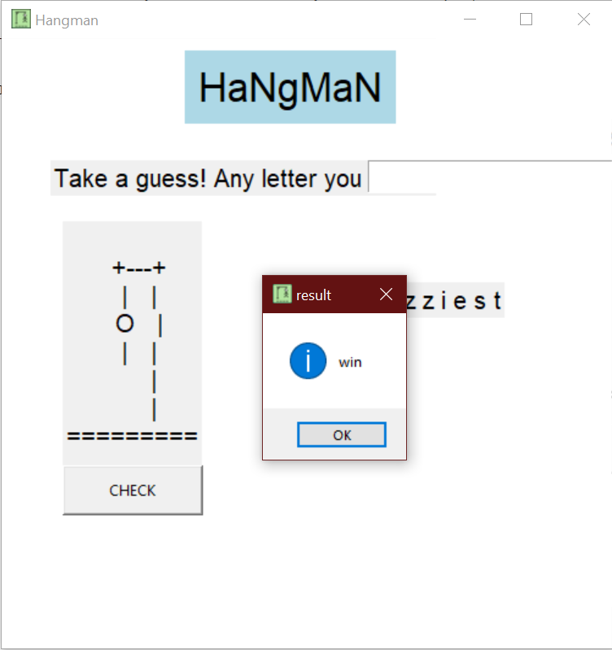

1. When you lose the game

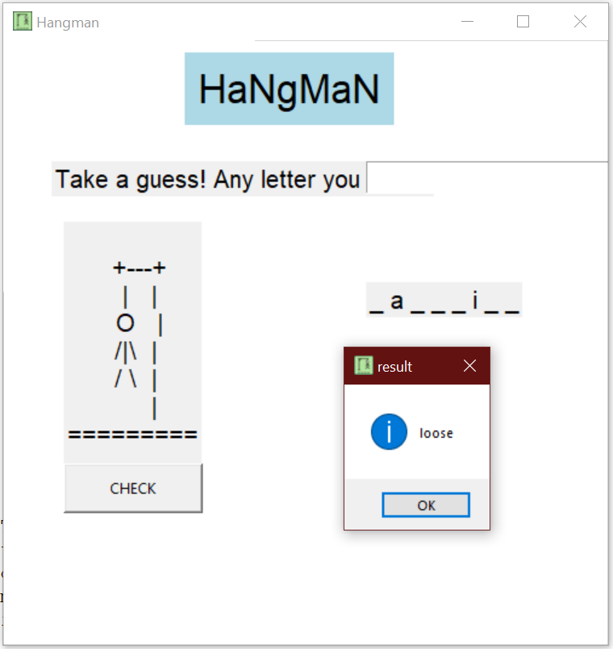

**Conclusion:-**

Tkinter was very useful in this project as it can run on almost all the platforms and very fast for smaller projects.

But many challenges also occurred like it was very difficult to change the size of the heading of the game.

The main problem we faced was to set the exact size of the frame and to adjust the all the elements according to the size of the frame.

So, there are many advantages of using this module. Hangman game is on the easier side that’s why it worked quite good with Tkinter and the needed things for this project were easily implemented.